Specification for ETL
from OMOP CDM v5 to PCORnet CDM v1
Revision Date: June 22, 2015

Table of Contents
Table of Contents 1
1.0 Introduction 2
2.0 Source Data Mapping Approach 2
3.0 Source Data Mapping 2
3.1 Data Mapping 2
3.1.1 Table: Demographic 2
3.1.2 Table: Enrollment 5
3.1.3 Table: Encounter 6
3.1.4 Table: Diagnosis 9
3.1.5 Table: Procedure 12
3.1.6 Table: Vital 13
3.1.7 Table: LAB_RESULT_CM 19
3.2 Appendix 1: OMOP CDMv5 Source Tables 23
3.3 Appendix 2: OMOP CDM Version 5.0 ERD 24
4.0 Outstanding Issues 30

Introduction
The purpose of this document is to provide a mechanism for PCORnet data partners to communicate information about how they transformed data stored in OMOP Common Data Model (CDM) Version 5 format into the PCORnet Common Data Model (CDM) Version 1.0. To describe how the information will be used to help the PCORnet Coordinating Center better understand the transformation process, appropriate uses of the PCORnet data, and the comparability of data sources. This document details the approach used for the Extract, Transform, and Load (ETL) process to transform OMOP CDMv5 data elements to the data elements in the PCORnet CDM Version 1.0.
The document, 2014-05-30g-PCORnet-Common-Data-Model-v1-0-RELEASE.pdf, should be used in conjunction with this document, as the PCORnet Common Data Model has the data types and descriptions of the PCORnet tables.
This document assumes that the conventions outlined in CDRN Conventions for Populating OMOP CDM were followed in populating the OMOP CDMv5 database. It also requires that OMOP Vocabulary 5 or later be used for the ETL.

Source Data Mapping Approach
This document describes mapping of the target PCORnet Common Data Model (CDM) tables and columns from source OMOP CDM model v5.
The mapping was designed based on OMOP CDM v5 specification, data samples, and PCORnet CDM specification. The mapping should provide sufficient information in order to design and develop ETL processes.

Source Data Mapping
This section describes mapping process and ETL conversions for transforming data from an OMOP CDM (source) to a PCORNet CDM (destination).

Data Mapping
Data mapping expects source and target data to be stored in any conventional relational database system per OMOP CDM v5 and PCORNet CDM v1 specifications respectively.

Table: Demographic
PCORI DEMOGRAPHIC table contains one record per patient. Load Demographic data from OMOP Person table as described below.
.
The field mapping is performed as follows:
Destination Field | Source Field | Applied Rule | Comment
PATID | Person.Person_id |  | Convert to text
BIRTH_DATE | Use Person.year_of_birth, month_of_birth and day_of_birth to construct date as text in 'YYYY-MM-DD' format. Substitute month and day (each) as '01' if not available in the source. | Format date as text 'YYYY-MM-DD'.
BIRTH_TIME | Person.time_of_birth | Use NULL if not available | Convert to text format ‘HH:MI’ using 24-hour clock and zero-padding for hour and minute
SEX | Person.gender_concept_id
  OMOP to PCORnet
  44814664 | A = Ambiguous
  8532 | F = Female
  8507 | M = Male
  44814650 | NI = No information
  44814653 | UN = Unknown
  44814649 | OT = Other
  0 | NULL
  OMOP Concepts
  44814664 | Ambiguous
  8532 | Female
  8507 | Male
  44814650 | No Information
  44814653 | Unknown
  44814649 | Other
  0 | Field does not exist in the source
HISPANIC | Derive from Person.ethnicity_concept_id
  OMOP to PCORnet
  38003563 | Y = Yes
  38003564 | N = No
  44814650 | NI = No information
  44814653 | UN = Unknown
  44814649 | OT = Other
  0 | NULL
  OMOP Concepts
  38003563 | Hispanic or Latino
  38003564 | Not Hispanic or Latino
  44814650 | No Information
  44814653 | Unknown
  44814649 | Other
  0 | Field does not exist in the source
RACE | Derive from Person.Race_Concept_id |  | The mapping for Race from OMOP to PCORnet is given in a table below.
BIOBANK_FLAG | Observation.value_as_concept_id | If at least one record in Specimen table for the patient exist or  in the Observation table observation_concept_id is 4001345 (Biobank flag) with  value_as_concept_id = 4188539 (Yes) then set biobank_flag as ‘Y’  else ‘N’ | The allowable values are ‘Y’ or ‘N’. The absence of a record indicates that there are no biobank specimens.
RAW_SEX | Person.gender_source_value
RAW_ HISPANIC | Person.ethnicity_source_value
RAW_RACE | Person.race_source_value

OMOP to PCORnet Race Mapping
OMOP |  | PCORnet
concept | description | Value
38003600 | African | 03 = Black or African American
38003599 | African American | 03 = Black or African American
38003573 | Alaska Native | 01 = American Indian or Alaska Native
38003572 | American Indian | 01 = American Indian or Alaska Native
8657 | American Indian or Alaska Native | 01 = American Indian or Alaska Native
38003616 | Arab | 05 = White
8515 | Asian | 02 = Asian
38003574 | Asian Indian | 02 = Asian
38003601 | Bahamian | 03 = Black or African American
38003575 | Bangladeshi | 02 = Asian
38003602 | Barbadian | 03 = Black or African American
38003576 | Bhutanese | 02 = Asian
38003598 | Black | 03 = Black or African American
8516 | Black or African American | 03 = Black or African American
38003577 | Burmese | 02 = Asian
38003578 | Cambodian | 02 = Asian
38003579 | Chinese | 02 = Asian
38003604 | Dominica Islander | 03 = Black or African American
38003603 | Dominican | 03 = Black or African American
38003614 | European | 05 = White
38003581 | Filipino | 02 = Asian
38003605 | Haitian | 03 = Black or African American
38003582 | Hmong | 02 = Asian
38003583 | Indonesian | 02 = Asian
38003593 | Iwo Jiman | 02 = Asian
38003606 | Jamaican | 03 = Black or African American
38003584 | Japanese | 02 = Asian
38003585 | Korean | 02 = Asian
38003586 | Laotian | 02 = Asian
38003597 | Madagascar | 02 = Asian
38003587 | Malaysian | 02 = Asian
38003594 | Maldivian | 02 = Asian
38003612 | Melanesian | 04 = Native Hawaiian or OtherPacific Islander
38003611 | Micronesian | 04 = Native Hawaiian or OtherPacific Islander
38003615 | Middle Eastern or North African | 05 = White
8557 | Native Hawaiian or Other Pacific Islander | 04 = Native Hawaiian or OtherPacific Islander
38003595 | Nepalese | 02 = Asian
38003588 | Okinawan | 02 = Asian
38003613 | Other Pacific Islander | 04 = Native Hawaiian or OtherPacific Islander
38003589 | Pakistani | 02 = Asian
38003610 | Polynesian | 04 = Native Hawaiian or OtherPacific Islander
38003596 | Singaporean | 02 = Asian
38003590 | Sri Lankan | 02 = Asian
38003580 | Taiwanese | 02 = Asian
38003591 | Thai | 02 = Asian
38003607 | Tobagoan | 03 = Black or African American
38003608 | Trinidadian | 03 = Black or African American
38003592 | Vietnamese | 02 = Asian
38003609 | West Indian | 03 = Black or African American
8527 | White | 05 = White
44814659 | Multiple Race | 06 = Multiple Race
44814660 | Refuse to answer | 07 = Refuse to answer
44814650 | No Information | NI = No information
44814653 | Unknown | UN = Unknown
44814649 | Other | OT = Other
0 | Field does not exist in the source | NULL

Table: Enrollment
The ENROLLMENT table has a start/stop structure that contains records for continuous enrollment periods.
“Enrollment” is an insurance-based concept that defines a period during which all medically-attended events are expected to be observed. For partners that do not have enrollment information for some of their patients, other approaches for identifying periods during which complete medical capture is expected can be used.
This table is designed to identify periods during which a person is expected to have complete data capture. Members with medical coverage, drug coverage, or both should be included.
A record is expected to represent a unique combination of PATID, ENR_START_DATE.
Currently OMOP CDM is using the earliest and latest encounter dates (‘E’), which is in violation of the PCORnet requirement. This is to be discussed with PCORnet.
The field mapping is as follows:
Destination Field | Source Field | Applied Rule | Comment
PATID | Observation_Period.person_id |  | Convert to text
ENR_START_DATE | Observation_Period.observation_period_start_date | Convert to text formatted as 'YYYY-MM-DD'
ENR_END_DATE | Observation_Period.observation_period_end_date | Convert to text formatted as 'YYYY-MM-DD'
CHART | Observation.value_as_concept_id where observation_type_concept_id = 4030450 (Patient chart) | Join to Observation table on person_id, observation_start_date and observation_type_concept_id = 4030450 (Patient chart). If the value_as_concept_id = 4188539 (Yes) then ‘Y’ else ‘N’ | The absence of an Observation record for a person for an Observation Period will be interpreted as No.
ENR_BASIS | Observation_Period.period_type_concept_id
  OMOP to PCORnet
  44814722 | I = Insurance
  44814723 | G = Geography
  44814725 | A = Algorithmic
  44814724 | E = Encounter Based
  OMOP Concepts
  44814722 | Insurance
  44814723 | Geography
  44814725 | Algorithmic
  44814724 | Encounter Based

Table: Encounter

The ENCOUNTER Table contains one record per PATID and ENCOUNTERID (which reflects a unique combination of PATID, ADMIT_DATE, PROVIDERID and ENC_TYPE).
The encounter table should include information on interactions between patients and providers. Each diagnosis and procedure recorded during the encounter should have a separate record in the Diagnosis or Procedure Tables.
Multiple visits to the same provider on the same day may be considered one encounter (especially if defined by a reimbursement basis); if so, the ENCOUNTER record should be associated with all diagnoses and procedures that were recorded during those visits.
The field mapping is performed as follows:
Destination Field | Source Field | Applied Rule | Comment
PATID | Visit_Occurrence.person_id |  | Convert to text
ENCOUNTERID | Visit_Occurrence.visit_occurrence_id
ADMIT_DATE | Visit_Occurrence.visit_start_date | Text. Format as 'YYYY-MM-DD'.
ADMIT_TIME | Visit_Occurrence.visit_start_time | If available format as ‘hh:mm:ss’ military time otherwise is should be NULL
DISCHARGE_DATE | Visit_Occurrence.visit_end_date | Text. Format as 'YYYY-MM-DD'.
DISCHARGE_TIME | Visit_Occurrence.visit_end_time | If available format as ‘hh:mm:ss’ otherwise is should be NULL
PROVIDERID | Visit_Occurrence.provider_id
FACILITY_LOCATION | Location.zip | Join Visit_Occurrence to Care_Site on care_site_id, then to Location on location_id. NULL if it cannot be derived. | Only if zipcode is available. Otherwise NULL  3-digit zip for PCORNet
ENC_TYPE | Visit_Occurrence.visit_concept_id
  OMOP to PCORnet
  9201 | IP = Inpatient Hospital Stay
  9202 | AV = Ambulatory Visit
  9203 | ED = Emergency Department
  42898160 | IS = Non-Acute Institutional Stay
  44814710 | IS = Non-Acute Institutional Stay
  44814711 | OA = Other Ambulatory Visit
  44814650 | NI = No information
  44814653 | UN = Unknown
  44814649 | OT = Other
  0 | NULL
  OMOP Concepts
  9201 | Inpatient Visit
  9202 | Outpatient Visit
  9203 | Emergency Room Visit
  42898160 | Long Term Care Visit
  44814710 | Non-Acute Institutional Stay
  44814711 | Other ambulatory visit
  44814650 | No information
  44814653 | Unknown
  44814649 | Other
  0 | Field does not exist in the source
FACILITYID | Visit_Occurrence.care_site_id
DISCHARGE_DISPOSITION | Based on Observation.value_as_concept_id – see Applied Rule column | Join to Observation table on visit_occurrence_id and observation_concept_id = 44813951 (Discharge details). The mapping below is based on the value_as_concept_id:
  OMOP to PCORnet
  4161979 | A = Discharged alive
  4216643 | E = Expired
  44814650 | NI = No information
  44814653 | UN = Unknown
  44814649 | OT = Other
  0 | NULL
  OMOP Concepts
  4161979 | Discharged alive
  4216643 | Patient died
  44814650 | No Information
  44814653 | Unknown
  44814649 | Other
  0 | Field does not exist in the source
DISCHARGE_STATUS | Based on Observation.value_as_concept_id – see Applied Rule column | Join to Observation table on visit_occurrence_id and observation_ concept_id = 4137274 (Discharge to establishment). The mapping below is based on the value_as_concept_id:
  OMOP to PCORnet
  38004205 | AF = Adult Foster Home
  38004301 | AL = Assisted Living Facility
  4021968 | AM = Against Medical Advice
  44814693 | AW = Absent without leave
  4216643 | EX = Expired
  38004195 | HH = Home Health
  8536 | HO = Home / Self Care
  8546 | HS = Hospice
  38004279 | IP = Other Acute Inpatient Hospital
  8676 | NH = Nursing Home (Includes ICF)
  8920 | RH = Rehabilitation Facility
  44814680 | RS = Residential Facility
  8717 | SH = Still In Hospital
  8863 | SN = Skilled Nursing Facility
  44814650 | NI = No information
  44814653 | UN = Unknown
  44814649 | OT = Other
  0 | NULL
  OMOP Concepts
  38004205 | Agencies, Foster Care Agency
  38004301 | Nursing & Custodial Care Facilities, Assisted Living Facility
  4021968 | Patient self-discharge against medical advice
  44814693 | Absent without leave
  4216643 | Patient died
  38004195 | Agencies, Home Health
  8536 | Home
  8546 | Hospice
  38004279 | Hospitals, General Acute Care Hospital
  8676 | Nursing Facility
  8920 | Comprehensive Inpatient Rehabilitation Facility:
  44814680 | Residential Facility
  8717 | Inpatient Hospital
  8863 | Skilled Nursing Facility
  44814650 | No information
  44814653 | Unknown
  44814649 | Other
  0 | No matching concept
DRG | Observation.Value_as_concept_id | Look for observation record associated with the visit with observation_concept_id = 3040464 (Hospital discharge DRG). If the record is not found or value_as_concept_id is 44814650 or 44814649 use NULL.  Only populate for IP (Inpatient), IS (Non-Acute Institutional Stay) and ED (Emergency Department) encounters. Use NULL for other encounter types. | Concepts from vocabulary_id = ‘DRG’ or
  OMOP Concepts
  44814650 | No information
  44814649 | Other
DRG_TYPE | See Applied Rule | OMOP CDMv5 does not have this information. Use the appropriate value from the vocabulary below:  01 = CMS-DRG (old system)  02 = MS-DRG (current system)  NI = No information  UN = Unknown  OT = Other | 02- double check
ADMITTING_SOURCE | Based on Observation.value_as_concept_id | Join to Observation table on visit_occurrence_id and observation_concept_id = 4145666 (Admission from Establishment). The mapping below is based on the value_as_concept_id:
  OMOP to PCORnet
  38004205 | AF = Adult Foster Home
  38004195 | HH = Home Health
  38004207 | AV = Ambulatory Visit
  8920 | RH = Rehabilitation Facility
  8870 | ED = Emergency Department
  8536 | HO = Home / Self Care
  8546 | HS = Hospice
  38004279 | IP = Other Acute Inpatient Hospital
  38004301 | AL = Assisted Living Facility
  8676 | NH = Nursing Home (Includes ICF)
  44814680 | RS = Residential Facility
  8863 | SN = Skilled Nursing Facility
  44814650 | NI = No information
  44814653 | UN = Unknown
  44814649 | OT = Other
  0 | NULL
  OMOP Concepts
  38004205 | Agencies, Foster Care Agency
  38004195 | Agencies, Home Health
  38004207 | Ambulatory Health Care Facilities, Clinic/Center, Ambulatory Surgical
  8920 | Comprehensive Inpatient Rehabilitation Facility
  8870 | Emergency Room - Hospital
  8536 | Home
  8546 | Hospice
  38004279 | Hospitals, General Acute Care Hospital
  38004301 | Nursing & Custodial Care Facilities, Assisted Living Facility
  8676 | Nursing Facility
  44814680 | Residential facility
  8863 | Skilled Nursing Facility
  44814650 | No Information
  44814653 | Unknown
  44814649 | Other
  0 | Field does not exist in the source
RAW_ ENC_TYPE | Visit_Occurrence.visit_source_value
RAW_ DISCHARGE_DISPOSITION | Observation.observation_source_value | Join to Observation table on visit_occurrence_id and observation_type_concept_id = 44813951 (Discharge details).  If data is not available populate with NULL.
RAW_ DISCHARGE_STATUS | Observation.observation_source_value | Join to Observation table on visit_occurrence_id and observation_type_concept_id = 4137274 (Discharge to establishment). If data is not available populate with NULL.
RAW_ DRG_TYPE | NULL
RAW_ ADMITTING_SOURCE | Observation.observation_source_value | Join to Observation table on visit_occurrence_id and observation_type_concept_id = 4145666 (Admission from Establishment).

Table: Diagnosis

DIAGNOSIS should capture all uniquely recorded diagnoses for all encounters, except those generated from problem lists. If a patient has multiple diagnoses associated with one encounter, then there should be one record in this table for each diagnosis. Exclude records from the OMOP CDM where the Condition Type Concept is EHR problem list entry (38000245).

If a local ontology is used, but cannot be mapped to a standard ontology such as ICD-9-CM, DX_TYPE should be populated as “Other”.
Note: The admit date for the diagnosis is copied from the encounter record which is the admission or appointment date, where in the OMOP CDM, the condition occurrence date is when the condition was defined. Therefore, it is possible that there will be more than one of the same diagnoses during a visit in the OMOP CDM. Duplicate records are also possible due to the mapping of one source code to multiple standard codes. These duplicated diagnoses should be reduced to a single record in PCORnet based on the following attributes: Condition_Occurrence.visit_occurrence_id, Condition_Occurrence.condition_source_value, Condition_Occurrence.condition_type_concept_id, and related Observation.value_as_concept_id (for Observation.concept_id = 4021918. ‘Qualifier for type of diagnosis).
The field mapping is performed as follows:
Destination Field | Source Field | Applied Rule | Comment
PATID | Condition_Occurrence.person_id |  | Convert to text
ENCOUNTERID | Condition_Occurrence.visit_occurrence_id
ENC_TYPE | Encounter.enc_type | Join to [target] Encounter table on Condition_Occurrence.visit_occurrence_id = Encounter.encounterid | Copied from ENCOUNTER record
ADMIT_DATE | Encounter.admit_date | Join to Encounter table on Condition_Occurrence.visit_occurrence_id = Encounter.encounterid | Text. Format as 'YYYY-MM-DD'.  Copied from ENCOUNTER record
PROVIDERID | Encounter.provider_id | Join to encounter table on Condition_Occurrence.visit_occurrence_id = Encounter.providerid | Copied from ENCOUNTER record
DX | Condition_Occurrence.condition_source_value  Otherwise,  Concept.concept_code | If condition_ source_concept_id is 44814649 (‘Other’), use Condition_Occurrence.condition_source_value.  Otherwise,  join condition_ source_concept_id to Concept.concept_id. | PCORnet expects to see all diagnosis codes as they were represented in the source system. Therefore, use source_concept_id or source_value to represent DX in the source coding system.
DX_TYPE | Derive from Concept.vocabulary_id | Join source_condition_concept_id to Concept.concept_id to get vocabulary_id  Otherwise  use ‘OT’ (‘Other’)
  OMOP to PCORnet Vocabulary Mapping
  ICD9CM | 09 = ICD-9-CM
  ICD10CM | 10 = ICD-10-CM
  SNOMED | SM = SNOMED CT
  PCORNet | OT = Other
  OMOP Vocabularies
  ICD9CM
  ICD10CM
  SNOMED
  PCORNet
DX_SOURCE | Derive from Observation.value_as_concept_id | Join to Fact_Relationship table on  fact_id_1 = condition_occurrence_id  domain_concept_id_1 = 19  domain_concept_id_2 = 27  relationship_concept_id = 0  and Observation table on  fact_id_2 = observation_id  and observation_concept_id isQualifier for type of diagnosis (4021918)  If record does not exist, then NULL.
  OMOP to PCORnet
  4203942 | AD = Admitting
  4230359 | FI = Final
  4033240 | IN = Interim
  44814650 | No Information
  44814653 | Unknown
  44814649 | Other
  OMOP Concepts
  4203942 | Admitting diagnosis
  4230359 | Final diagnosis
  4033240 | Preliminary diagnosis
  44814650 | No Information
   | Unknown
  44814649 | Other
PDX | Derive from Condition_Occurrence.condition_type_concept_id | If condition_type_concept_id = 44786627  Then 'P' (Principal)  Else If condition_type_concept_id =  44786629  Then 'S' (Secondary)  Else  If respective Visit_Occurrence.visit_concept_id are  9202 (Outpatient Visit)  9203 (Emergency Room Visit)  44814711 (Other ambulatory visit)  Then ‘X’ (Unable to Classify)  Else | Only Primary Condition (44786627)  and Secondary Condition(44786629)  are relevant. Also, relevant only to IS and IP encounter types.
  OMOP to PCORnet
  44814650 | No Information
  44814653 | Unknown
  44814649 | Other
RAW_DX | Condition_Occurrence.condition_source_value |  | Load source values 'as is' - with source-specific suffixes and prefixes.
RAW_ DX_TYPE | Concept.vocabulary_id | If condition_ source_concept_id is 44814649 (‘Other’), use ‘OT’ (‘Other’).  Otherwise, join condition_source_concept_id to Concept.concept_id
RAW_ DX_SOURCE | Observation.observation_source_value | Join to Fact_Relationship table on  fact_id_1 = condition_occurrence_id  domain_concept_id_1 = 19  domain_concept_id_2 = 27  relationship_concept_id = 0  and Observation table on  fact_id_2 = observation_id  and observation_concept_id is Qualifier for type of diagnosis (4021918)
RAW_ PDX | Concept.concept_name | If condition_type_concept_id IN(44786627, 44786629 ) join to Concept.concept_id  Otherwise  NULL | Primary Condition (44786627)  Secondary Condition (44786629)

Table: Procedure
The PROCEDURE Table contains one record per unique combination of PATID, ENCOUNTERID, PX, and PX_TYPE. Because the date in the procedure table is that of the encounter, not necessarily when the procedure was performed, there may be multiples of the same procedure for the person/encounter/date when selecting from the OMOP procedure table. Duplicate records are also possible due to the mapping of one source code to multiple standard codes. These duplicated procedure records should be reduced to a single record in PCORnet based on procedure_occurrence.visit_occurrence_id and procedure_occurrence. procedure_source_value.
In OMOP CDM Procedure_Occurrence.visit_occurrence_id is optional, however PCORNet CDM specification requires mandatory encounter id for DIAGNOSIS and PROCEDURE. Exclude procedures where the visit_occurrence_id is NULL.
The field mapping is performed as follows:
Destination Field | Source Field | Applied Rule | Comment
PATID | Procedure_Occurrence.person_id |  | Convert to text
ENCOUNTERID | Procedure_Occurrence.visit_occurrence_id |  | .
ENC_TYPE | Encounter.enc_type | Join to [target] Encounter table on Procedure_Occurrence.visit_occurrence_id = Encounter.encounterid | Copied from ENCOUNTER record
ADMIT_DATE | Encounter.admit_date | Join to Encounter table on Procedure_Occurrence.visit_occurrence_id = Encounter.encounterid | Text. Format as 'YYYY-MM-DD'.  Copied from ENCOUNTER record
PROVIDERID | Encounter.provider_id | Join to encounter table on Procedure_Occurrence.visit_occurrence_id = Encounter.providerid | Copied from ENCOUNTER record.
PX | procedure_occurrence.procedure_source_value  Otherwise  Concept.concept_code | If procedure_source_concept_id is 44814649 (‘Other’), use procedure_occurrence. procedure_source_value.  Otherwise  join procedure_ source_concept_id to Concept.concept_id. | PCORnet expects to see all procedure codes as they were represented in the source system. Therefore, use source_concept_id or source_value to represent PX in the source coding system.
PX_TYPE | Derive from Concept.vocabulary_id | Join procedure_source_concept_id to Concept.concept_id to get vocabulary_id  Otherwise  Use ‘OT’ (‘Other’).
  OMOP to PCORnet Vocabulary Mapping
  ICD9CM | 09 = ICD-9-CM
  ICD9Proc | 09 = ICD-9-CM
  ICD10PCS | 10 = ICD-10-PCS
  CPT4 | C4 = CPT-4 (i.e., HCPCS Level I)
  HCPCS | HC = HCPCS (i.e., HCPCS Level II)
  LOINC | LC = LOINC
  NDC | ND = NDC
  Revenue Code | RE = Revenue
  PCORNet | OT = Other
  OMOP Vocabulary Codes
  ICD9CM
  ICD9Proc
  ICD10PCS
  CPT4
  HCPCS
  LOINC
  NDC
  Revenue Code
  PCORNet
RAW_PX | Procedure_Occurrence.procedure_source_value
RAW_PX_TYPE | Concept.concept_id | If source_condition_concept_id is 44814649 (‘Other’), use ‘OT’ (‘Other’).  Otherwise, join procedure_source_concept_id to Concept.concept_id

Table: Vital

Multiple measurements per encounter can be populated (for example, 3 blood pressure readings). There will be records where not all the vital statistics are defined. Create a record any time there is at least one of the attributes, weight, blood pressure, height or BMI is defined.
Vital signs data are sourced from OMOP Measurement and Observation tables.
Records corresponding to one visit may be grouped into one Vital record or represented as one Vital record per one vital sign.
Systolic and diastolic blood pressure coming from the same measurement must be by grouped into one record by utilizing Fact_Relationship link between the two records in the Measurement table as follows. Fact_id_1 and fact_id_2 should be equal to the respective measurement_id of diastolic and systolic BP records. Domain_concept_id_1 and domain_concept_id_2 should be equal to 21 (‘Measurement’). Relationship_concept_id should be equal to 46233682 (‘Diastolic to systolic blood pressure measurement’).
The field mapping between OMOP Measurement table and PCORnet VITAL table are as follows:
Destination Field | Source Field | Applied Rule | Comment
PATID | Measurement.person_id |  | Convert to text
ENCOUNTERID | Measurement.visit_occurrence_id  or  NULL |  | Arbitrary encounter-level identifier. This is an optional relationship; the ENCOUNTERID should be present if the vitals were measured as part of healthcare delivery: Measurement.measurement_type_concept_id = ‘Observation Recorded from EHR’ (38000276).
MEASURE_DATE | Measurement. measurement_date | Text. Format as 'YYYY-MM-DD'.
MEASURE_TIME | Measurement.measurement_time | Text. Format as 'HH:MI' as 24 hours clock with zero-padding for hours and minutes.
VITAL_SOURCE | Measurement. measurement_type_concept_id |  | Relevant OMOP concepts are: ‘Patient reported’ (44814721) or ‘Observation Recorded from EHR’ (38000276).  If multiple vital signs are compiled together in one record, Measurement.measurement_Type_Concept_ID must be the same.
  OMOP to PCORnet
  44814721 | PR = Patient-reported
  38000276 | HC = Healthcare delivery setting
  All other codes | OT = Other
HT | Measurement.value_as_number | Where Measurement .measurement_concept_id = 3036277 (Body height)  Parse the string and convert to inches. | Have to parse string which is in format of 9’9.9’’ to inches.
WT | Measurement.value_as_number | Where Measurement .measurement_concept_id = 3025315 (Body weight)  Divided by 16 to get pounds | Have to convert from ounces to pounds. Round to pounds.
DIASTOLIC | Measurement.value_as_number | Where Measurement .measurement_concept_id in (3012888, 3034703, 3019962, 3013940 )
SYSTOLIC | Measurement.value_as_number | Where Measurement .measurement_concept_id in (3004249, 3018586, 3035856, 3009395 )
ORIGINAL_BMI | Measurement.value_as_number | Where Measurement .measurement_concept_id = 3038553 (Body mass index)
BP_POSITION | derived from Measurement.measurement_concept_id | NULL if no blood pressure reading in this record. | Position when blood pressure taken is derived from the diastolic and systolic code provided.
  Concept | Description | PCORnet Value
  3034703 | Diastolic Blood Pressure - Sitting | ‘01’
  3019962 | Diastolic Blood Pressure - Standing | ‘02’
  3013940 | Diastolic Blood Pressure - Supine | ‘03’
  3012888 | Diastolic BP | ‘NI’
  3018586 | Systolic Blood Pressure - Sitting | ‘01’
  3035856 | Systolic Blood Pressure - Standing | ‘02’
  3009395 | Systolic Blood Pressure - Supine | ‘03’
  3004249 | Systolic BP | ‘NI’
RAW_ VITAL_SOURCE | Measurement.measurement_source_value | Derived from Measurement. measurement_Type_Concept_ID for a respective vital sign.  Measurement.measurement_Type_Concept_ID values: | If multiple vital signs are compiled together in one record, Observation.Observation_Type_Concept_ID must be the same.
  OMOP to PCORnet
  44814721 | Patient-reported
  38000276 | Healthcare delivery setting
  All other codes | Other
RAW_ DIASTOLIC | Measurement.measurement_source_value | Where Measurement .measurement_concept_id in (3012888, 3034703, 3019962, 3013940 )
  OMOP Concepts
  3012888 | BP diastolic
  3034703 | Diastolic blood pressure--sitting
  3019962 | Diastolic blood pressure--standing
  3013940 | Diastolic blood pressure--supine
RAW_ SYSTOLIC | Measurement.measurement_source_value | Measurement .measurement_concept_id in (3004249, 3018586, 3035856, 3009395 )
  OMOP Concepts
  3004249 | BP systolic
  3018586 | Systolic blood pressure--sitting
  3035856 | Systolic blood pressure--standing
  3009395 | Systolic blood pressure--supine
RAW_ BP_POSITION | NULL |  | Not available

Tobacco status and tobacco type Observation records are grouped into one VITAL record by utilizing Fact_Relationship link between the two records in the Observation table as follows. Fact_id_1 and fact_id_2 should be equal to the respective observation_id of tobacco status and tobacco type records. Domain_concept_id_1 and domain_concept_id_2 should be equal to 27 (‘Observation’). Relationship_concept_id should be equal to TBD. There may be multiple tobacco type records per one tobacco status record. PCORnet TOBACCO_TYPE is determined based on the combination of OMOP tobacco type concepts as described below.
The field mapping between OMOP Observation table and PCORnet VITAL table are as follows:
Destination Field | Source Field | Applied Rule | Comment
PATID | Observation.person_id |  | Convert to text
ENCOUNTERID | Observation.visit_occurrence_id  or  NULL |  | Arbitrary encounter-level identifier. This is an optional relationship; the ENCOUNTERID should be present if the vitals were measured as part of healthcare delivery: Observation.Observation_type_concept_id = ‘Observation Recorded from EHR’ (38000276).
MEASURE_DATE | Observation. Observation_date | Text. Format as 'YYYY-MM-DD'.
MEASURE_TIME | Observation.Observation_time | Text. Format as 'HH:MI' as 24 hours clock with zero-padding for hours and minutes.
VITAL_SOURCE | Observation. Observation_type_concept_id |  | Relevant OMOP concepts are: ‘Patient reported’ (44814721) or ‘Observation Recorded from EHR’ (38000276).  If multiple vital signs are compiled together in one record, Observation.Observation_Type_Concept_ID must be the same.
  OMOP to PCORnet
  44814721 | PR = Patient-reported
  38000276 | HC = Healthcare delivery setting
  All other codes | OT = Other
TOBACCO | Observation.value_as_concept_id | Where Observation.observation_concept_id = 4275495 (‘Tobacco smoking behavior - finding’)
  OMOP to PCORnet
  4209585 | 08 = Light tobacco smoker
  4209006 | 07 = Heavy tobacco smoker
  4044778 | 07 = Heavy tobacco smoker
  42709996 | 01 = current every day smoker
  Occasional tobacco smoker | 02 = current some day smoker
  4298794 | 05 = Smoker, current status unknown
  4144272 | 04 = Never smoker
  4222303 | OT = Other
  4310250 | 03 = Former smoker
  4141786 | 06 = Unknown if ever smoked
  44814650 | NI = No Information
  44814649 | OT = Other
  OMOP Concepts
  Concept ID | Concept Name
  4209585 | Moderate smoker (20 or less per day)
  4209006 | Heavy smoker (over 20 per day)
  4044778 | Chain smoker
  42709996 | Smokes tobacco daily
  TBD | Occasional tobacco smoker
  4298794 | Smoker
  4144272 | Never smoked tobacco
  4222303 | Non-smoker
  4310250 | Ex-smoker
  4141786 | Tobacco smoking consumption(status) unknown
  44814650 | No Information
  44814649 | Other
TOBACCO_TYPE | Observation.value_as_concept_id | If a fact for Observation.observation_concept_id = 4275495 (‘Tobacco smoking behavior - finding’) is linked to a fact for Observation.observation_concept_id = 4298794 (‘Smoker’) in Fact_Relationship table, use the following values for Observation.observation_concept_id = 4298794  If a fact for Observation.observation_concept_id = 4275495 (‘Tobacco smoking behavior - finding’) is not linked to a fact for Observation.observation_concept_id = 4298794 (‘Smoker’) in Fact_Relationship table, use the following values for Observation.observation_concept_id = 4275495
  OMOP to PCORnet
  Any of:  4276526,  4298794  But not any of:  4246415,  4218917,  4144272,  4222303 | 01 = Cigarettes only
  Any of:  4246415,  4218917,  4144272,  4222303  But not any of:  4276526,  4298794 | 02 = Other tobacco only
  4276526 and any of the (424615, 4218917)  Or  4298794 and any of the (4052949, 4052465) | 03 = Cigarettes and other tobacco
  44814653 | UN
  44814650 | NI
  44814649 | OT
  OMOP to PCORnet
  4222303,  4144272 | 04 = None
  4141786,  4209585,  4209006,  42709996,  Occasional tobacco smoker,  4298794,  4310250 | NULL
  44814653 | UN
  44814650 | NI
  44814649 | OT
  OMOP Concepts for Tobacco Smoking Status
  Concept ID | Concept Name
  4209585 | Moderate smoker (20 or less per day)
  4209006 | Heavy smoker (over 20 per day)
  42709996 | Smokes tobacco daily
  TBD | Occasional tobacco smoker
  4298794 | Smoker
  4144272 | Never smoked tobacco
  4222303 | Non-smoker
  4310250 | Ex-smoker
  44814653 | Unknown
  44814650 | No Information
  44814649 | Other
  OMOP Concepts for Tobacco Type
  Concept ID | Concept Name
  4276526 | Cigarette smoker
  4246415 | Cigar smoker
  4218917 | Pipe smoker
  4298794 | Ex-cigarette smoker
  4144272 | Ex-cigar smoker
  4222303 | Ex-pipe smoker

Table: LAB_RESULT_CM
The LAB_RESULT_CM table contains one record per LAB_RESULT_CM_ID.
Only records with actual lab results should be included in this table. If the results suggest that the test was run (e.g., result is “borderline”) include it. But if the test is not resulted for any reason then do not include it.
The source for Lab results in OMOP CDM is the Measurement table, all measurement recordss where Measurement.measurement_type_concept_id is 44818702 (‘Lab result’). In OMOP CDM, lab tests are represented by LOINC codes. The following LAB_RESULT_CM fields are derived from the LOINC codes: LAB_NAME, LAB_LOINC, SPECIMEN_SOURCE, and RESULT_UNIT. Mappings for selected LOINC codes between OMOP concepts and these attributes are presented in the table below. This list will have to be expanded as the list of target LOINC codes grow.
PCORnet Lab Name | OMOP Concept ID | LAB_NAME | LAB_LOINC | SPECIMEN_SOURCE | RESULT_UNIT
Troponin I cardiac | 3021337 | TROP_I | 10839-9 | SR_PLS | NG/ML
Creatinine kinase MB/creatinine kinase total | 3007150 | CK-MBI | 12187-1 | SR_PLS | PERCENT
Creatinine | 3016662 | CREATININE | 12190-5 | OT | MG/DL
Low-density lipoprotein | 3028288 | LDL | 13457-7 | SR_PLS
Creatinine kinase MB | 3005785 | CK_MB | 13969-1 | SR_PLS | NG/ML
Low-density lipoprotein | 3009966 | LDL | 18262-6 | SR_PLS | MG/DL
Creatinine kinase MB/creatinine kinase total | 3016311 | CK-MBI | 20569-0 | SR_PLS | PERCENT
Low-density lipoprotein | 3028437 | LDL | 2089-1 | SR_PLS | MG/DL
Creatinine kinase total | 3007220 | CK | 2157-6 | SR_PLS | U/L
Creatinine | 3016723 | CREATININE | 2160-0 | SR_PLS | MG/DL
Low-density lipoprotein | 3001308 | LDL | 22748-8 | SR_PLS
Creatinine kinase MB | 3029790 | CK_MB | 32673-6 | SR_PLS | U/L
Troponin T cardiac (qualitative) | 3042837 | Trop_T_QL | 33204-9 | SR_PLS
Creatinine | 3051825 | CREATININE | 38483-4 | BLOOD | MG/DL
Troponin I cardiac | 3033745 | TROP_I | 42757-5 | BLOOD | NG/ML
Low-density lipoprotein | 3046549 | LDL | 43727-7 | SR_PLS | OT
Hemoglobin A1c | 3004410 | A1C | 4548-4 | BLOOD | PERCENT
Low-density lipoprotein | 3053190 | LDL | 47213-4 | SR_PLS
Troponin T cardiac (qualitative) | 3048529 | Trop_T.QN | 48425-3 | BLOOD | UG/L
Troponin T cardiac (qualitative) | 3052931 | Trop_T_QL | 48426-1 | BLOOD
Creatinine kinase MB/creatinine kinase total | 3048863 | CK-MBI | 49136-5 | SR_PLS
Low-density lipoprotein | 40757565 | LDL | 54434-6 | SR_PLS | OT
Low-density lipoprotein | 40758569 | LDL | 55440-2 | SR_PLS | MG/DL
Creatinine kinase MB | 3017761 | CK_MB | 5912-1 | SR_PLS
International normalized ratio | 3022217 | INR | 6301-6 | PPP
Troponin T cardiac (qualitative) | 3019572 | Trop_T.QN | 6597-9 | OT | UG/L
Troponin T cardiac (qualitative) | 3019800 | Trop_T.QN | 6598-7 | SR_PLS | UG/L
Hemoglobin | 3000963 | HGB | 718-7 | BLOOD | G/DL

The field mapping between OMOP and PCORnet CDM is performed as follows:

Destination Field | Source Field | Applied Rule | Comment
LAB_RESULT_CM_ID | Measurement.measurement _id |  | Convert to text
PATID | Measurement.person_id |  | Convert to text
ENCOUNTERID | Measurement.visit_occurrence_id  or  NULL |  | Arbitrary encounter-level identifier. This is an optional relationship; the ENCOUNTERID should be present if the labs were taken as part of healthcare delivery
LAB_NAME | Measurement.measurement_concept_id | Derived from Measurement. measurement_concept_id., see the mapping table above.
SPECIMEN_SOURCE | Measurement.measurement_concept_id | Derived from Measurement. measurement_concept_id., see the mapping table above.
LAB_LOINC | Measurement.measurement_concept_id | Derived from Measurement. measurement_concept_id., see the mapping table above.
PRIORITY | NULL |  | Not populated
RESULT_LOC | NULL |  | Not populated
LAB_PX | NULL |  | Not populated
LAB_PX_TYPE | NULL |  | Not populated
LAB_ORDER_DATE | NULL |  | Not populated
SPECIMEN_DATE | Measurement.measurement_date
SPECIMEN_TIME | Measurement.measurement_time | Text. Format as 'HH:MI' as 24 hours clock with zero-padding for hours and minutes.
RESULT_DATE | NULL |  | Not populated
RESULT_TIME | NULL |  | Not populated
RESULT_QUAL | Measurement.value_as_concept_id |  | Not populated for the PCORnet required labs but may be populated for other labs.
RESULT_NUM | Measurement.value_as_number
RESULT_MODIFIER | Concept.concept_code | Derived by linking Measurement.measurement_source_concept_id to Concept.concept_ id.
  OMOP to PCORnet
  4171756 | LT = Less than
  4171754 | LE = Less than or equal to
  4172703 | EQ = Equal
  4172704 | GT = Greater than
  4171755 | GE = Greater than or equal to
  OMOP Concepts for Operators
  Concept ID | Concept Name
  4171756 | <
  4171754 | <=
  4172703 | =
  4172704 | >
  4171755 | >=
RESULT_UNIT | Measurement.measurement_concept_id | Derived from Measurement. measurement_concept_id., see the mapping table above.
NORM_RANGE_LOW | NULL |  | Not populated
NORM_MODIFIER_LOW | NULL |  | Not populated
NORM_RANGE_HIGH | NULL |  | Not populated
NORM_MODIFIER_HIGH | NULL |  | Not populated
ABN_IND | NULL |  | Not populated
RAW_ LAB_NAME | Measurement.measurement_source_value
RAW_ LAB_CODE | Concept.concept_code | Derived by linking Measurement.measurement_source_concept_id to Concept.concept_id
RAW_ PANEL | NULL |  | Not populated
RAW_ RESULT | Measurement.value_source_value
RAW_ UNIT | Measurement.unit_source_value
RAW_ ORDER_DEPT | NULL
RAW_ FACILITY_CODE | NULL

Appendix 1: OMOP CDMv5 Source Tables
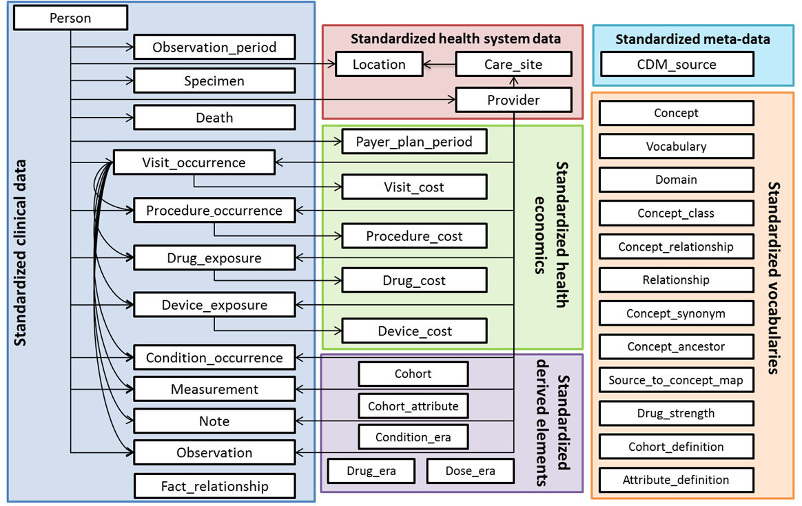

Appendix 2: OMOP CDM Version 5.0 ERD
Standardized Vocabularies entity-relationship diagram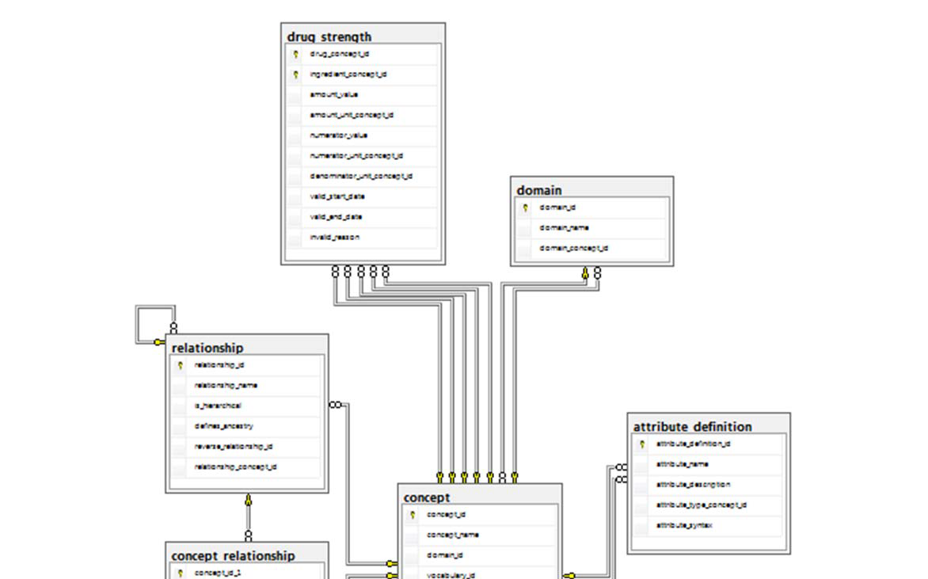 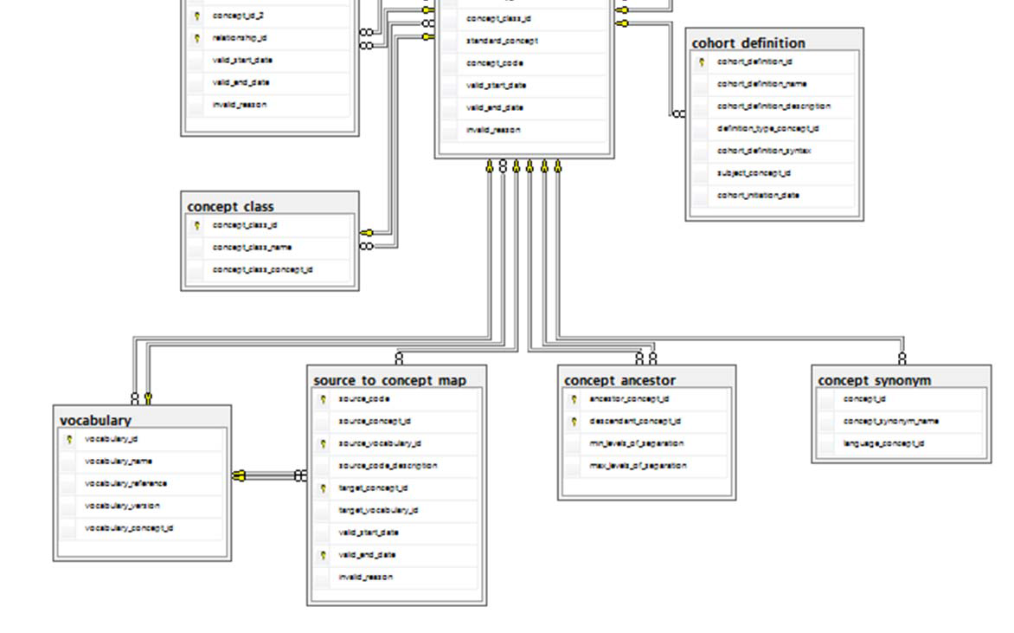
Standardized Clinical Data Tables Entity Relationship Diagram
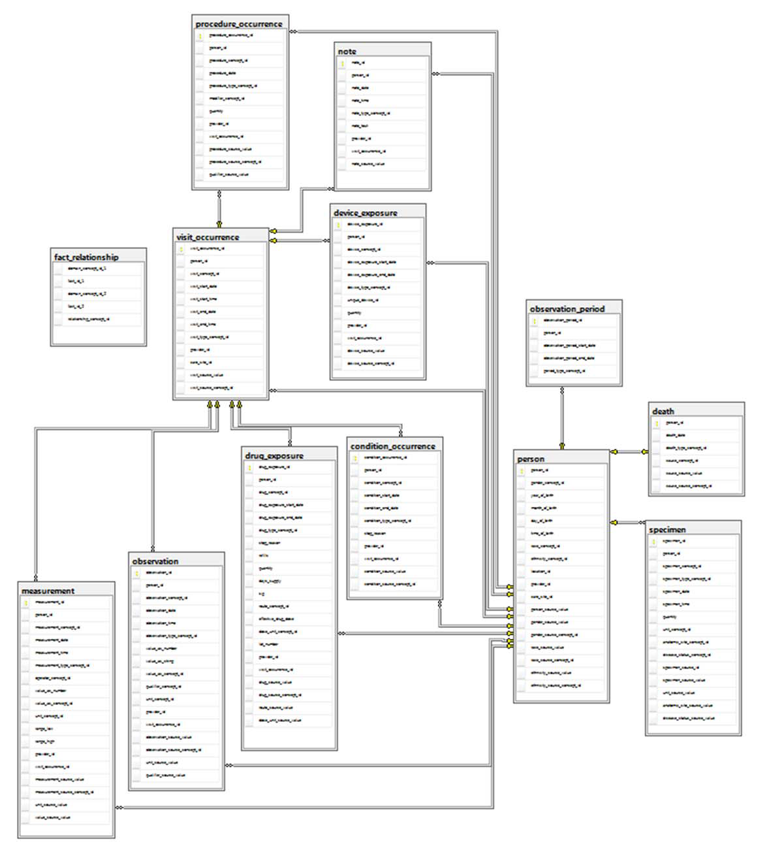

Standardized Health System Data Entity Relationship Diagram
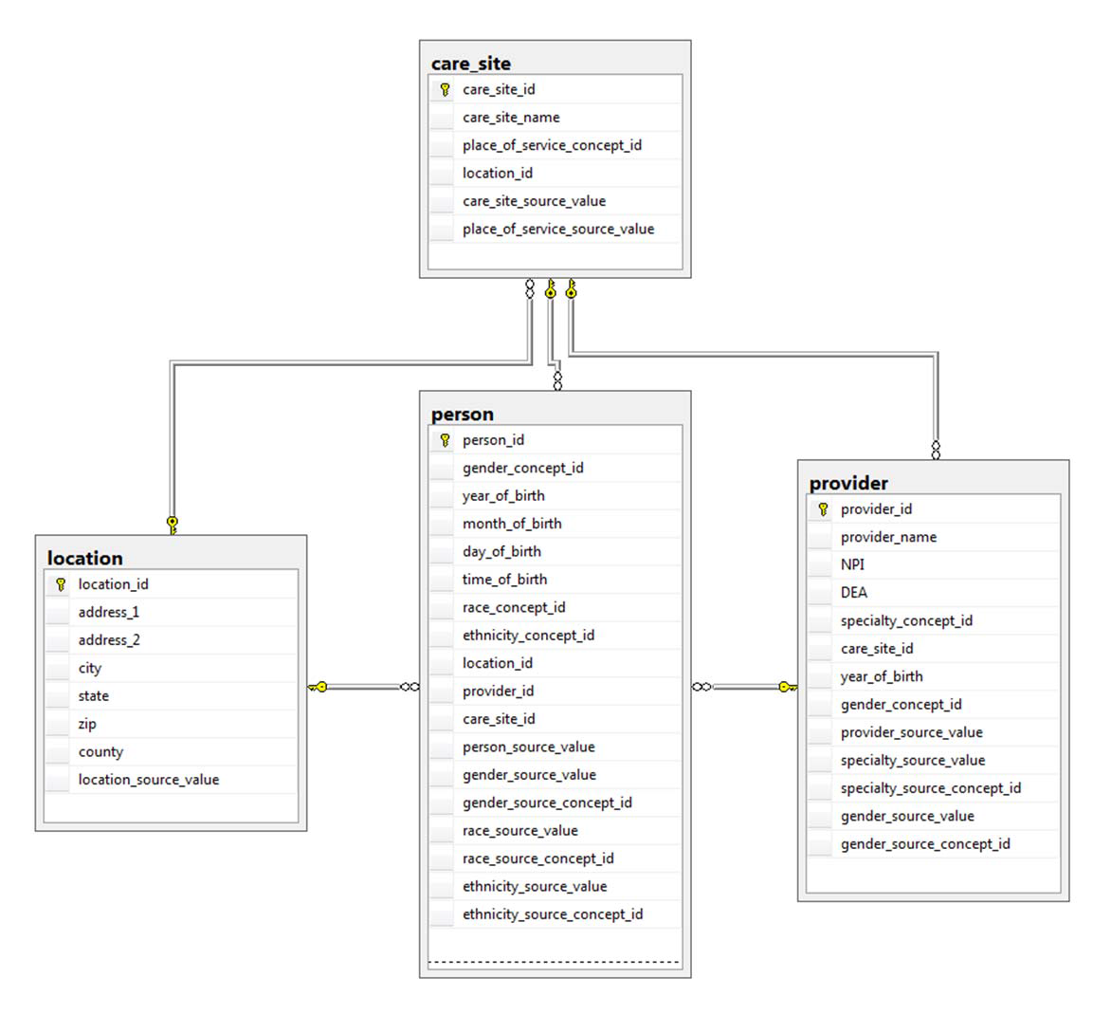
Standardized Health Economic Data Entity Relationship Diagram
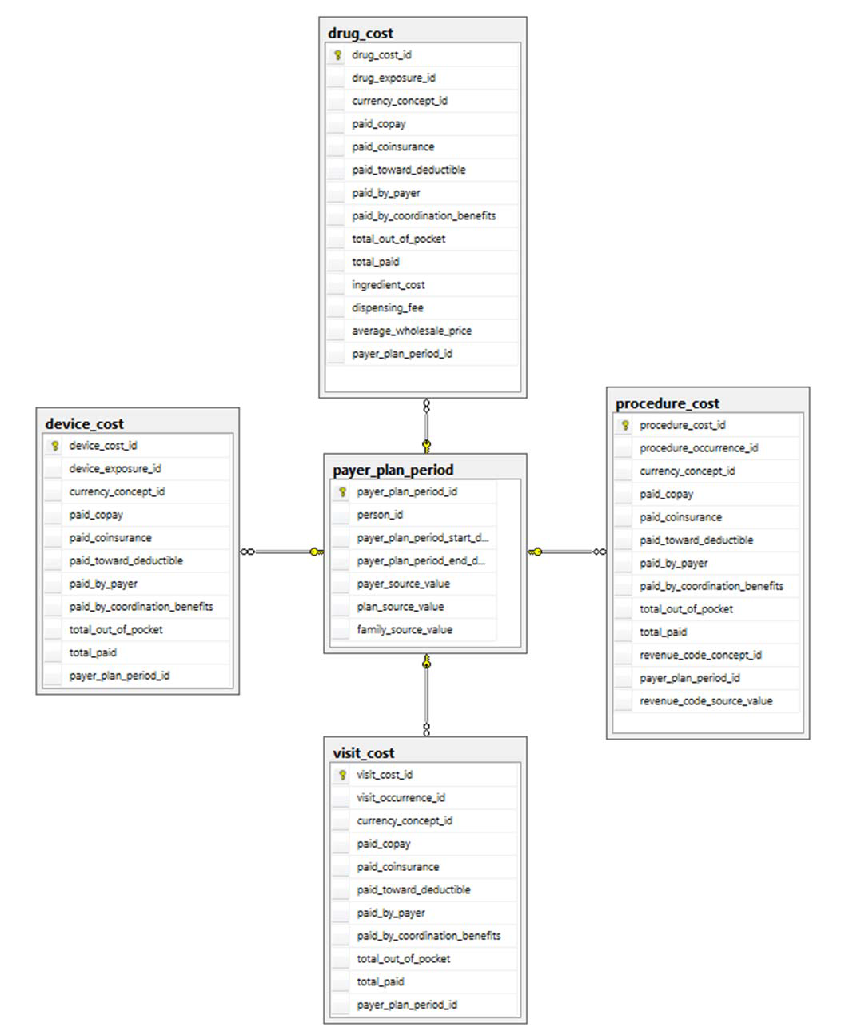
Standardized Derived Elements Entity Relationship Diagram
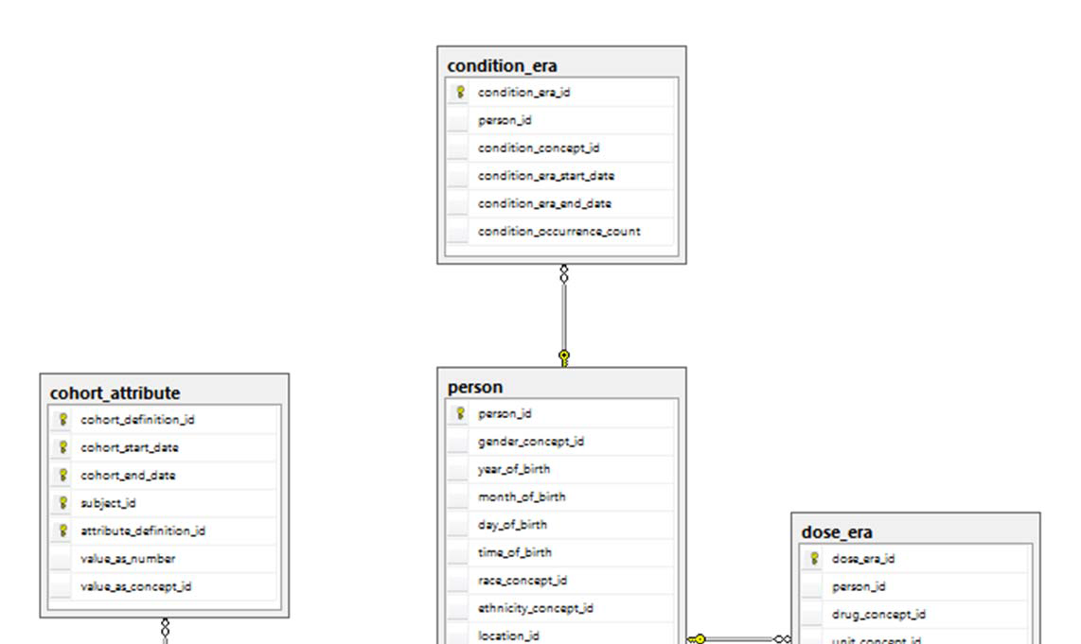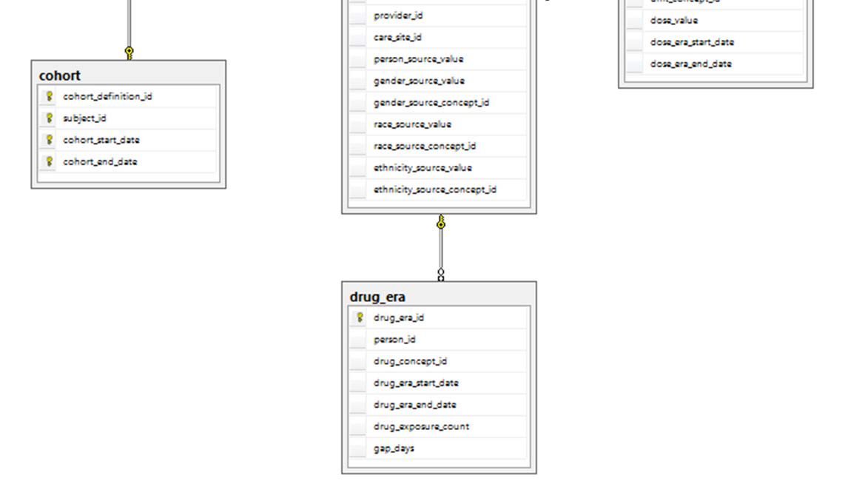
Standardized Metadata Entity Relationship Diagram
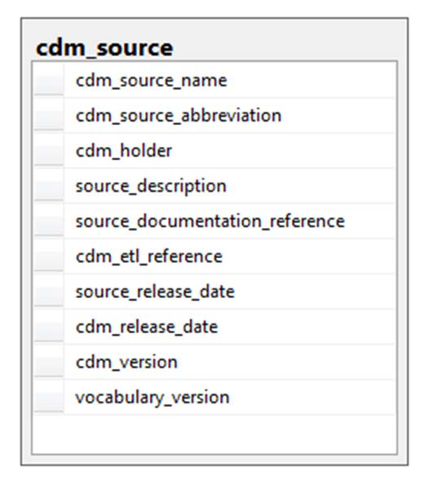

Outstanding Issues
Immediate
- Check with Chris is concept 44814723 has been corrected: ‘Period while enrolled in study’ should be changed to ‘Geography based’.

Parking lot
- TBD: Enrollment Period: PCORNet table could be sourced from either the Observation_Period or the Pay Plan Period in OMOP. Derviing from Pay Plan Period needs to be done.
- TBD: Do we transfer to PCORI ‘invalid’ DX’s? For example ‘250.x’ Indicates diabetes but it is not a valid ICD9 code. Those will be stored in OMOP with source_concept_id=0. If yes, will we have DX_TYPE of ‘Other’? Need PCORnet feedback

